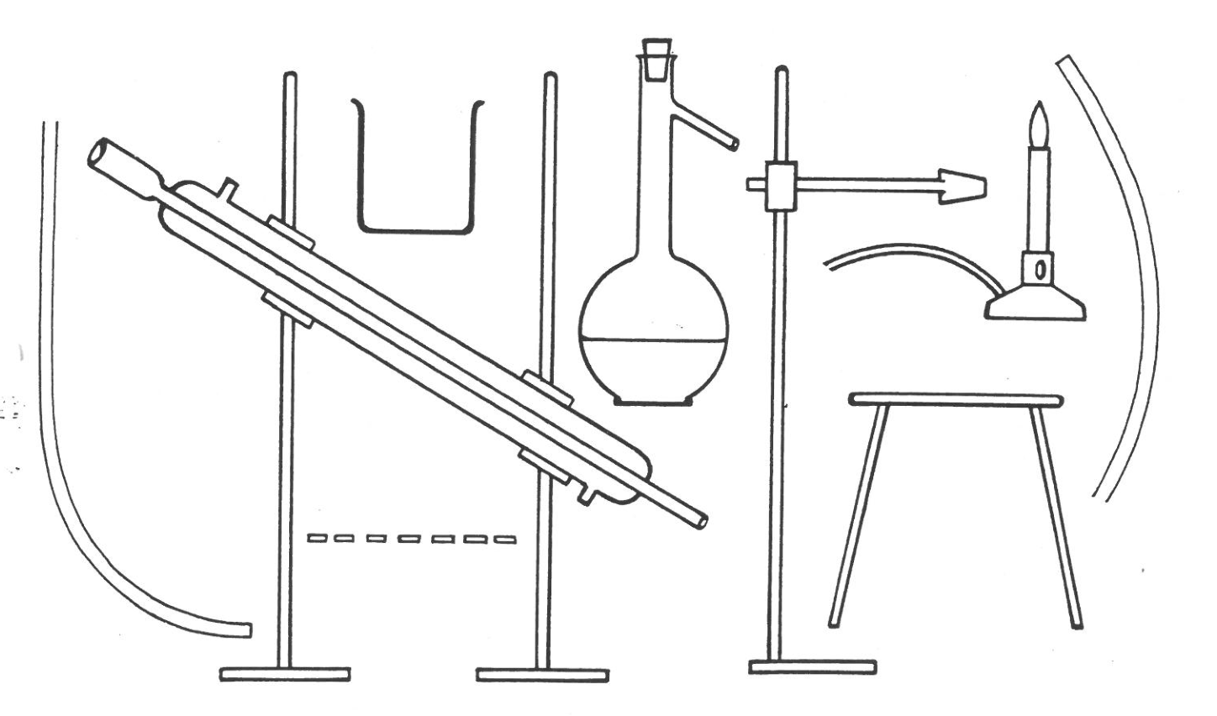

Cut out each piece of distillation equipment and assemble into a still. Add the labels below to your diagram.

|  |  |  |
| --- | --- | --- |
| Bunsen burner | Beaker | Tubing |
| Retort stand, boss head and clamp | Condenser | Solution/round bottom flask |
| Tripod | Tubing | Gauze mat |